Response to the Reviewers’ Comments for TIA-2026-IPCC-0540
Manuscript Title: Design and Implementation of a Non-coupled Integrated Transformer for a Two-phase Interleaved Flyback PFC Rectifier

Oct 25, 2026

Dear Editor,

We would like to express our sincere appreciation to the reviewers for going through our response letter and first revision of our manuscript. We found their constructive and insightful comments really helpful in the preparation of the next revision. The manuscript was revised once again in accordance with the comments and suggestions of the reviewers:

- Thank you very much to Reviewer #1 for accepting our previous revisions.
- Pages 2 to 12 correspond to Reviewer #2’s comments.
- Pages 13 to 22 correspond to Reviewer #3’s comments.
We revised the manuscript accordingly to the reviewers’ comments. In particular, we added a summary of the literature review in the form of a table, gave insights on the PF and THD, and PFC capability of the topology with the proposed magnetic component, and also commented on the system-level efficiency. We also updated the manuscript to improve clarity, consistency, and minor errors.

We hope the manuscript is now acceptable for publication.

Best Regards,
Sihoon Choi
Corresponding author,
Institute of Materials and Systems for Sustainability, Nagoya University
Email: choi.sihoon.w4@f.mail.nagoya-u.ac.jp

To Reviewer 2
We authors appreciate your valuable comments. The revised parts are indicated by red texts in the manuscript.
Comments to the Author
- The analytical explanation of the inherent DCM PFC mechanism is now clearer. However, the experimental verification remains insufficient. Please report measured PF and input-current THD, preferably at representative operating points.
We sincerely thank the reviewer for the valuable feedback and for acknowledging the clarity of our analytical explanation. We completely agree that the power factor PF and input-current THD are critical metrics for PFC flyback rectifiers. However, because the inherent DCM PFC mechanism is already a well-known and established characteristic, our physical prototype was constructed without a grid-side EMI filter to focus on validating the magnetic decoupling of the proposed integrated core. We would also like to emphasize that the proposed magnetic integration does not alter the fundamental electrical principle of the converter. The inherent DCM PFC mechanism remains identical to that of a conventional topology utilizing discrete transformers. To rigorously demonstrate this, we have conducted a comprehensive simulation in PLECS Standalone 5.0 with a standard differential-mode EMI filter (L_{f} = 100 $μ$H, C_{f} = 1 $μ$F) to obtain an accurate estimate.

As shown in the table below, we also compared the proposed integrated transformer against a conventional interleaved flyback baseline using two discrete transformers with matched magnetizing inductance L_{m} of 82.8 $μH$ and turns ratio n = 3. The topology with the proposed magnetic component can preserve PFC, exhibiting PF and input-current THD performance that closely matches the conventional discrete setup across the extremes of the operating range, maintaining PF > 0.95 at all representative points.

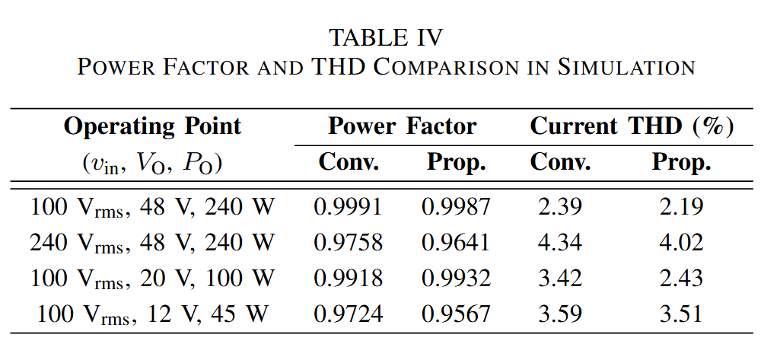

We have added simulated PFC waveforms as well in two operating points as a visual reference for the reviewers. As can be seen in the figure below, PFC occurs.

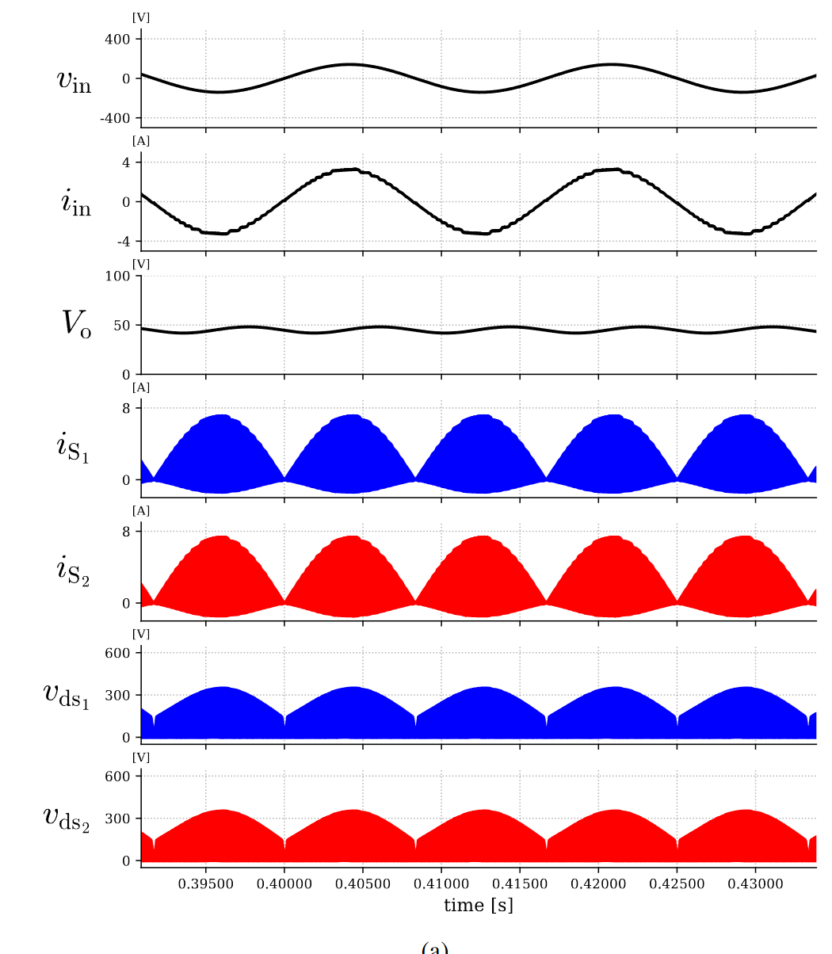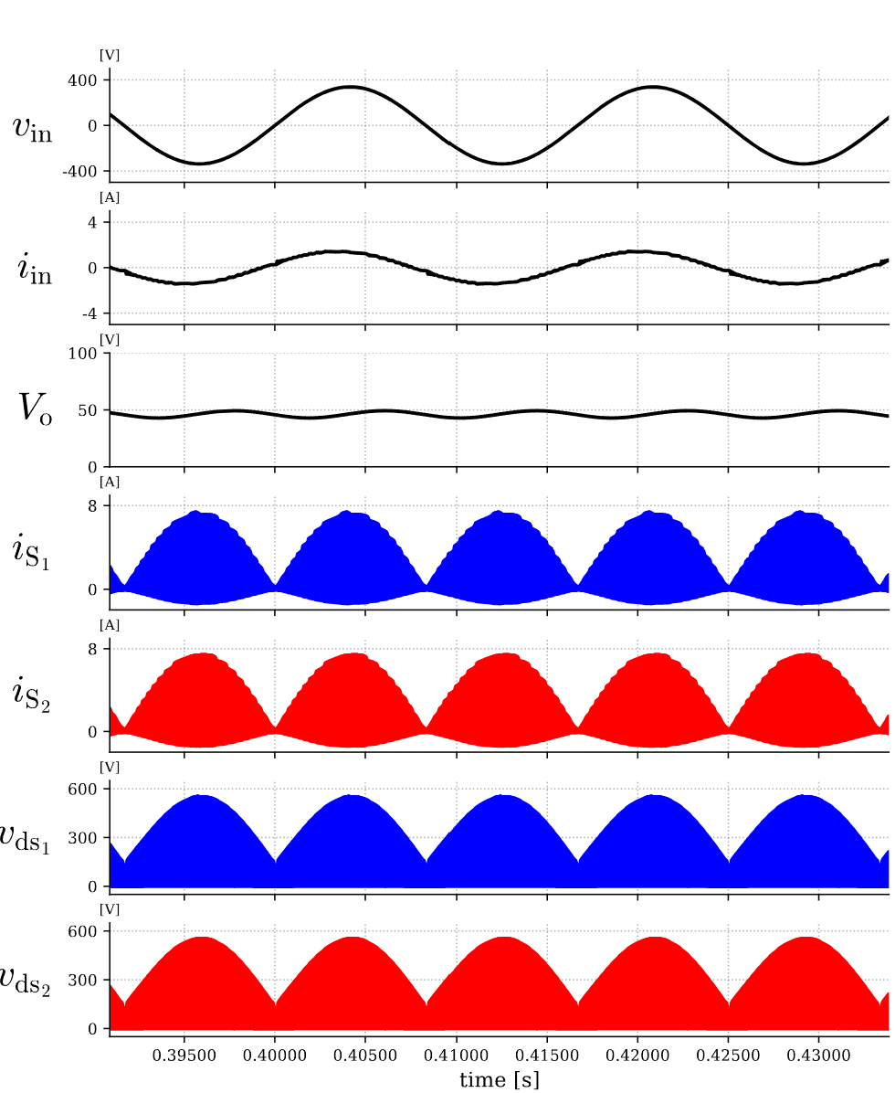
(a) (b)
Fig. Key simulated PFC waveforms of the proposed two-phase interleaved flyback rectifier showing v_{in}, v_{o}, i_{in}, i_{S1} and
i_{S2}, and v_{ds1} and v_{ds2} with v_{in}, V_{out}, and P_{O} of: (a) 100 V_{rms}, 48 V, and 240 W and (b) 240 V_{rms}, 48 V, and 240 W.

We have added these analyses in Section III-B to reflect these changes and clarifications as indicated below.
Before revision | After revision
N/A | (in Section III-B, after the 1st paragraph)  Furthermore, to substantiate the PFC capability of the proposed integrated structure, a performance analysis was conducted across several operating points. For reference, the proposed design was compared against a conventional two-phase interleaved flyback rectifier utilizing two discrete transformers with an identical n = 3 and L_{m} = 82.8 $μ$H. To extract clean grid-side AC waveforms and accurately evaluate harmonic distortion, a standard differential-mode EMI filter with L_{f} = 100 $μ$H, C_{f} = 1 $μ$F was incorporated into the simulation model.  As summarized in Table IV, the proposed non-coupled integrated transformer maintains a high PF of >0.95 and low current THD across various input voltages and load conditions. Crucially, the fundamental decoupling of the magnetic structure ensures that its PF and THD performance remains nearly identical to that of the conventional discrete implementation and additionally validates the claims of inherent PFC operation in DCM in Section II. To provide a clear visual reference of this capability, the simulated PFC waveforms at the operating points of $v_{in}$, $V_{O}$, and $P_{O}$ of 100 V_{rms}, 48 V, and 240 W, and 100 V_{rms}, 48 V, and 240 W are shown in Fig. 13(a) and Fig. 13(b) respectively.
N/A | (Newly added Table IV)  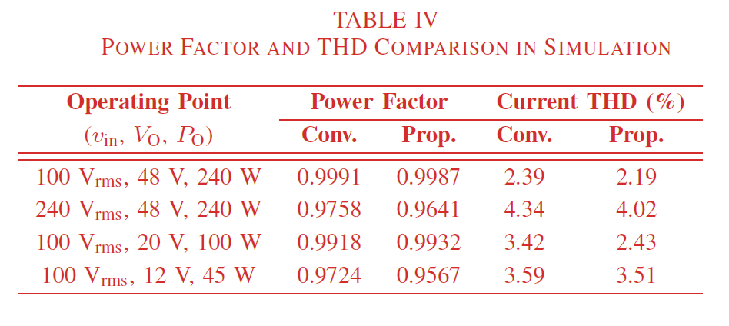
N/A | (Newly added Fig. 13)  (a)  (b)  Fig. 13. Key simulated PFC waveforms of the proposed two-phase interleaved flyback rectifier with v_{in}, V_{out}, and P_{O} of: (a) 100 V_{rms}, 48 V, and 240 W and (b) 240 V_{rms}, 48 V, and 240 W.

- The added time-domain analysis satisfactorily explains the variation over one line cycle. Nevertheless, the manuscript should also clarify the variation of peak switch current and peak flux density when the RMS input voltage changes from 100 to 240 V, including the corresponding duty-cycle adjustment. Please identify the actual worst-case operating condition for switch current and core flux density.
We sincerely thank the reviewer for the valuable feedback and for acknowledging the clarity of our revised theoretical analysis. We completely agree that clarifying the component stresses across the universal input voltage range (100 V_{rms} to 240 V_{rms}) provides a more comprehensive understanding of the operating limits of the converter as a whole.
To address the variation in peak switch current and peak flux density, we must look at how the duty cycle D adjusts with the RMS input voltage v_{in}. In a two-phase interleaved flyback PFC rectifier operating in DCM delivering constant output power P_{O} under the same magnetizing inductance L_{m} and same switching period T_{s}, D is inversely proportional to the peak input voltage ${\text{V}}_{\text{i}{\text{n}}_{\text{max}}}$ governed by (30) in the manuscript, which directly follows from reference [6] of the manuscript:
$$D=\frac{2}{V_{in_{max}}}\sqrt{\frac{0.5L_{m}P_{o}}{T_{s}}}$$
When V_{in} increases from 100 V_{rms} to 240 V_{rms}, if a control loop is added, it will naturally decrease $D$ to maintain the same power transfer. If the adjusted $D$ is substituted into (2) and (4) in the manuscript, the absolute peak switch current ${\text{I}}_{{\text{S}}_{\text{pk}\left(\text{max}\right)}}$ which is at the peak of the AC line cycle, is given as:
$$I_{S_{pk\left(max\right)}}=\frac{V_{in_{max}}}{L_{m}}DT_{s}=\frac{V_{in_{max}}}{L_{m}}\left(\frac{2}{V_{in_{max}}}\sqrt{\frac{0.5L_{m}P_{o}}{T_{s}}}\right)T_{s}=2\sqrt{\frac{0.5P_{o}T_{s}}{L_{m}}}$$
As shown, the $V_{in_{max}}$ term mathematically cancels out. Moreover, from (3) and (5) in the manuscript, it follows that ${\text{I}}_{{\text{S}}_{\text{pk}\left(\text{max}\right)}}$and the absolute peak core flux density B_{pk(max)} remain theoretically constant across the entire 100 V to 240 V input range.
However, the worst-case operating condition for the RMS current is the lowest input voltage at 100 V_{rms}. While the peak current remains constant, D reaches its absolute maximum at 100 V_{rms}. Consequently, the RMS currents in the switches and transformer windings are maximized at 100 V_{rms}, leading to the highest conduction losses and winding losses. Factoring in the practical drop in efficiency at lower line voltages, the peak current will be slightly higher at 100 ${\text{V}}_{\text{rms}}$ to compensate for these losses, cementing it as the worst-case condition for current stress and core saturation. Conversely, the highest input voltage 240 ${\text{V}}_{\text{rms}}$ is the worst-case condition for the switch voltage stress ${\text{V}}_{\text{d}{\text{s}}_{\text{max}}}$. We have added a new paragraph to the end of Section II-A to explicitly clarify this dynamic across the universal input voltage range and clearly identify the worst-case conditions for the readers.
The simulation and experimental waveforms in Fig. 12 and 17 (Fig. 18 in the revised manuscript) respectively were taken under the worst-case operating conditions and show that the converter can operate without any problem with the integrated transformer. This is also clarified in the paper as follows.
Before revision | After revision
N/A | (After Section II-B).  C. Worst-Case Operating Conditions  To properly evaluate the converter and size the components across the universal input range $v_{in}$ 100 ${\text{V}}_{\text{rms}}$ to 240 ${\text{V}}_{\text{rms}}$, it is critical to identify the worst-case operating conditions. In a two-phase interleaved flyback PFC rectifier operating in DCM and delivering constant output power $P_{o}$, $D$ is inversely proportional to $V_{in_{pk}}$, which directly follows from [6] and is expressed in (16):  $$D=\frac{2}{V_{in_{pk}}}\sqrt{\frac{0.5L_{m}P_{o}}{T_{s}}} (16)$$  From (2) and (4), using (8), it can be shown that the absolute peak switch currents $i_{S_{1_{pk} (max)}}$, $i_{S_{2_{pk} (max)}}$ , which occur at the peak of the AC line voltage cycle, remain constant across the entire input range and are theoretically independent of v_{in}. It also follows from (3) and (5) that the absolute peak magnetic flux densities ${B'}_{o_{1_{pk} (max)}}$, ${B''}_{o_{2_{pk} (max)}}$ and ${B''}_{c_{pk}(max)}$ remain constant across the entire $v_{in}$ of 100 V_{rms} to 240 V_{rms}.  However, while the peaks remain constant, $D$ reaches its absolute maximum at the lowest $v_{in}$. Consequently, the RMS currents in the switches and transformer windings are maximized at the lowest $v_{in}$. Conversely, the highest input voltage of 240 V_{rms} dictates the worst-case condition for the switch voltage stress v_{ds}.  D. Transformer Design Method  ….

- The expanded literature survey is appreciated. However, the requested comprehensive comparison would be considerably clearer in tabulated form.
We sincerely thank the reviewer for the positive feedback regarding the expanded literature survey and for this highly constructive recommendation. We agree that a tabulated format significantly improves the clarity and accessibility of the state-of-the-art comparison. In accordance with the suggestion, we have introduced a comprehensive comparison table in Section I-A of the revised manuscript. We present the table here as follows.

Before revision | After revision
(in Section I, 11th Paragraph)  Structural decoupling approaches have been explored to bypass these circulating currents and accommodate the variable load requirements of USB PD, offering an alternative to control-based phase shedding. Some approaches design decouples phases by separating the flux paths using 3-D orthogonal flux core geometries [34], [35]. However, these custom cores constrain commercial manufacturability and increases fabrication costs. Another proposed solution is an integrated nonlinear coupled inductor designed to decouple four phases at light loads [18]. Achieving this variable coupling requires  customized, multi-piece L- and T-shaped core assemblies with manually configured geometries, introducing tight assembly tolerances and manufacturing complexity. | (in Section I, 11th Paragraph)  Structural decoupling approaches have been explored to bypass these circulating currents and accommodate the variable load requirements of USB PD, offering an alternative to control-based phase shedding. Some approaches design decouples phases by separating the flux paths using 3-D orthogonal flux core geometries [34], [35]. However, these custom cores constrain commercial manufacturability and increases fabrication costs. Another proposed solution is an integrated nonlinear coupled inductor designed to decouple four phases at light loads [18]. Achieving this variable coupling requires  customized, multi-piece L- and T-shaped core assemblies with manually configured geometries, introducing tight assembly tolerances and manufacturing complexity. To clarify the operational trade-offs among these existing approaches, a comprehensive comparison of state-of-the-art interleaved flyback topologies and their magnetic configurations is summarized in Table I.

Before revision | After revision
N/A | (Newly added Table I)  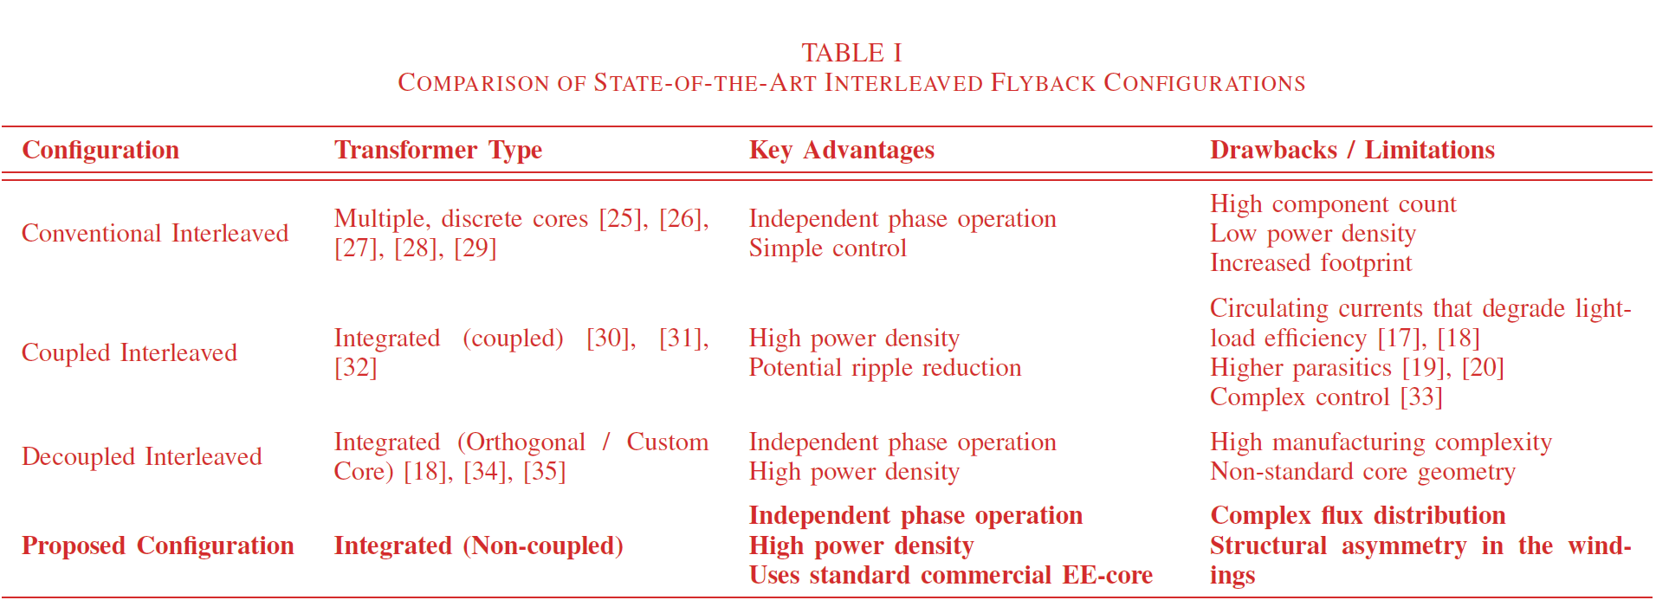

- Although the quality of the experimental waveforms has improved, the waveform traces should be thickened further to enhance visibility and readability.
We thank the reviewer for pointing this out. We completely agree that the visibility and readability of the experimental results are paramount. We have revised all experimental waveform figures by thickening the traces once again and improving the overall contrast for maximum clarity. Please see the updated waveforms below, which have now been incorporated into the revised manuscript.

Before revision | After revision
(in Section V, Fig. 17)  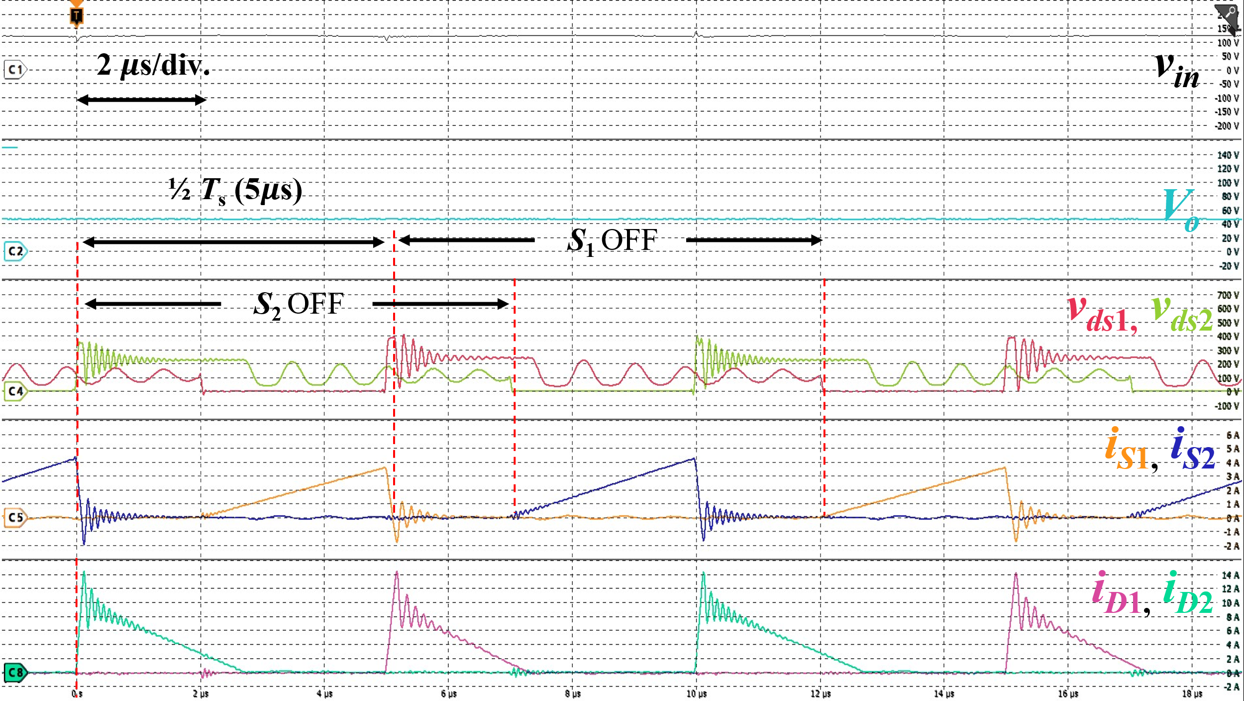  (b)  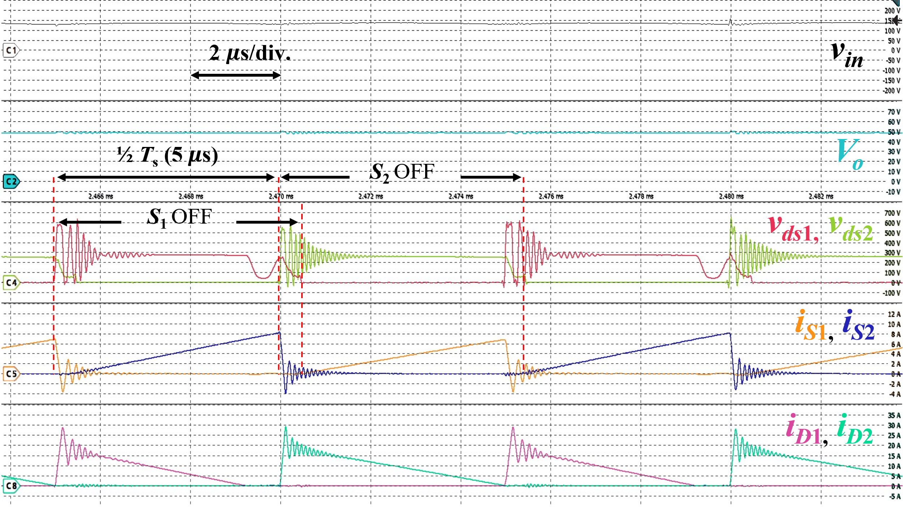  (c)  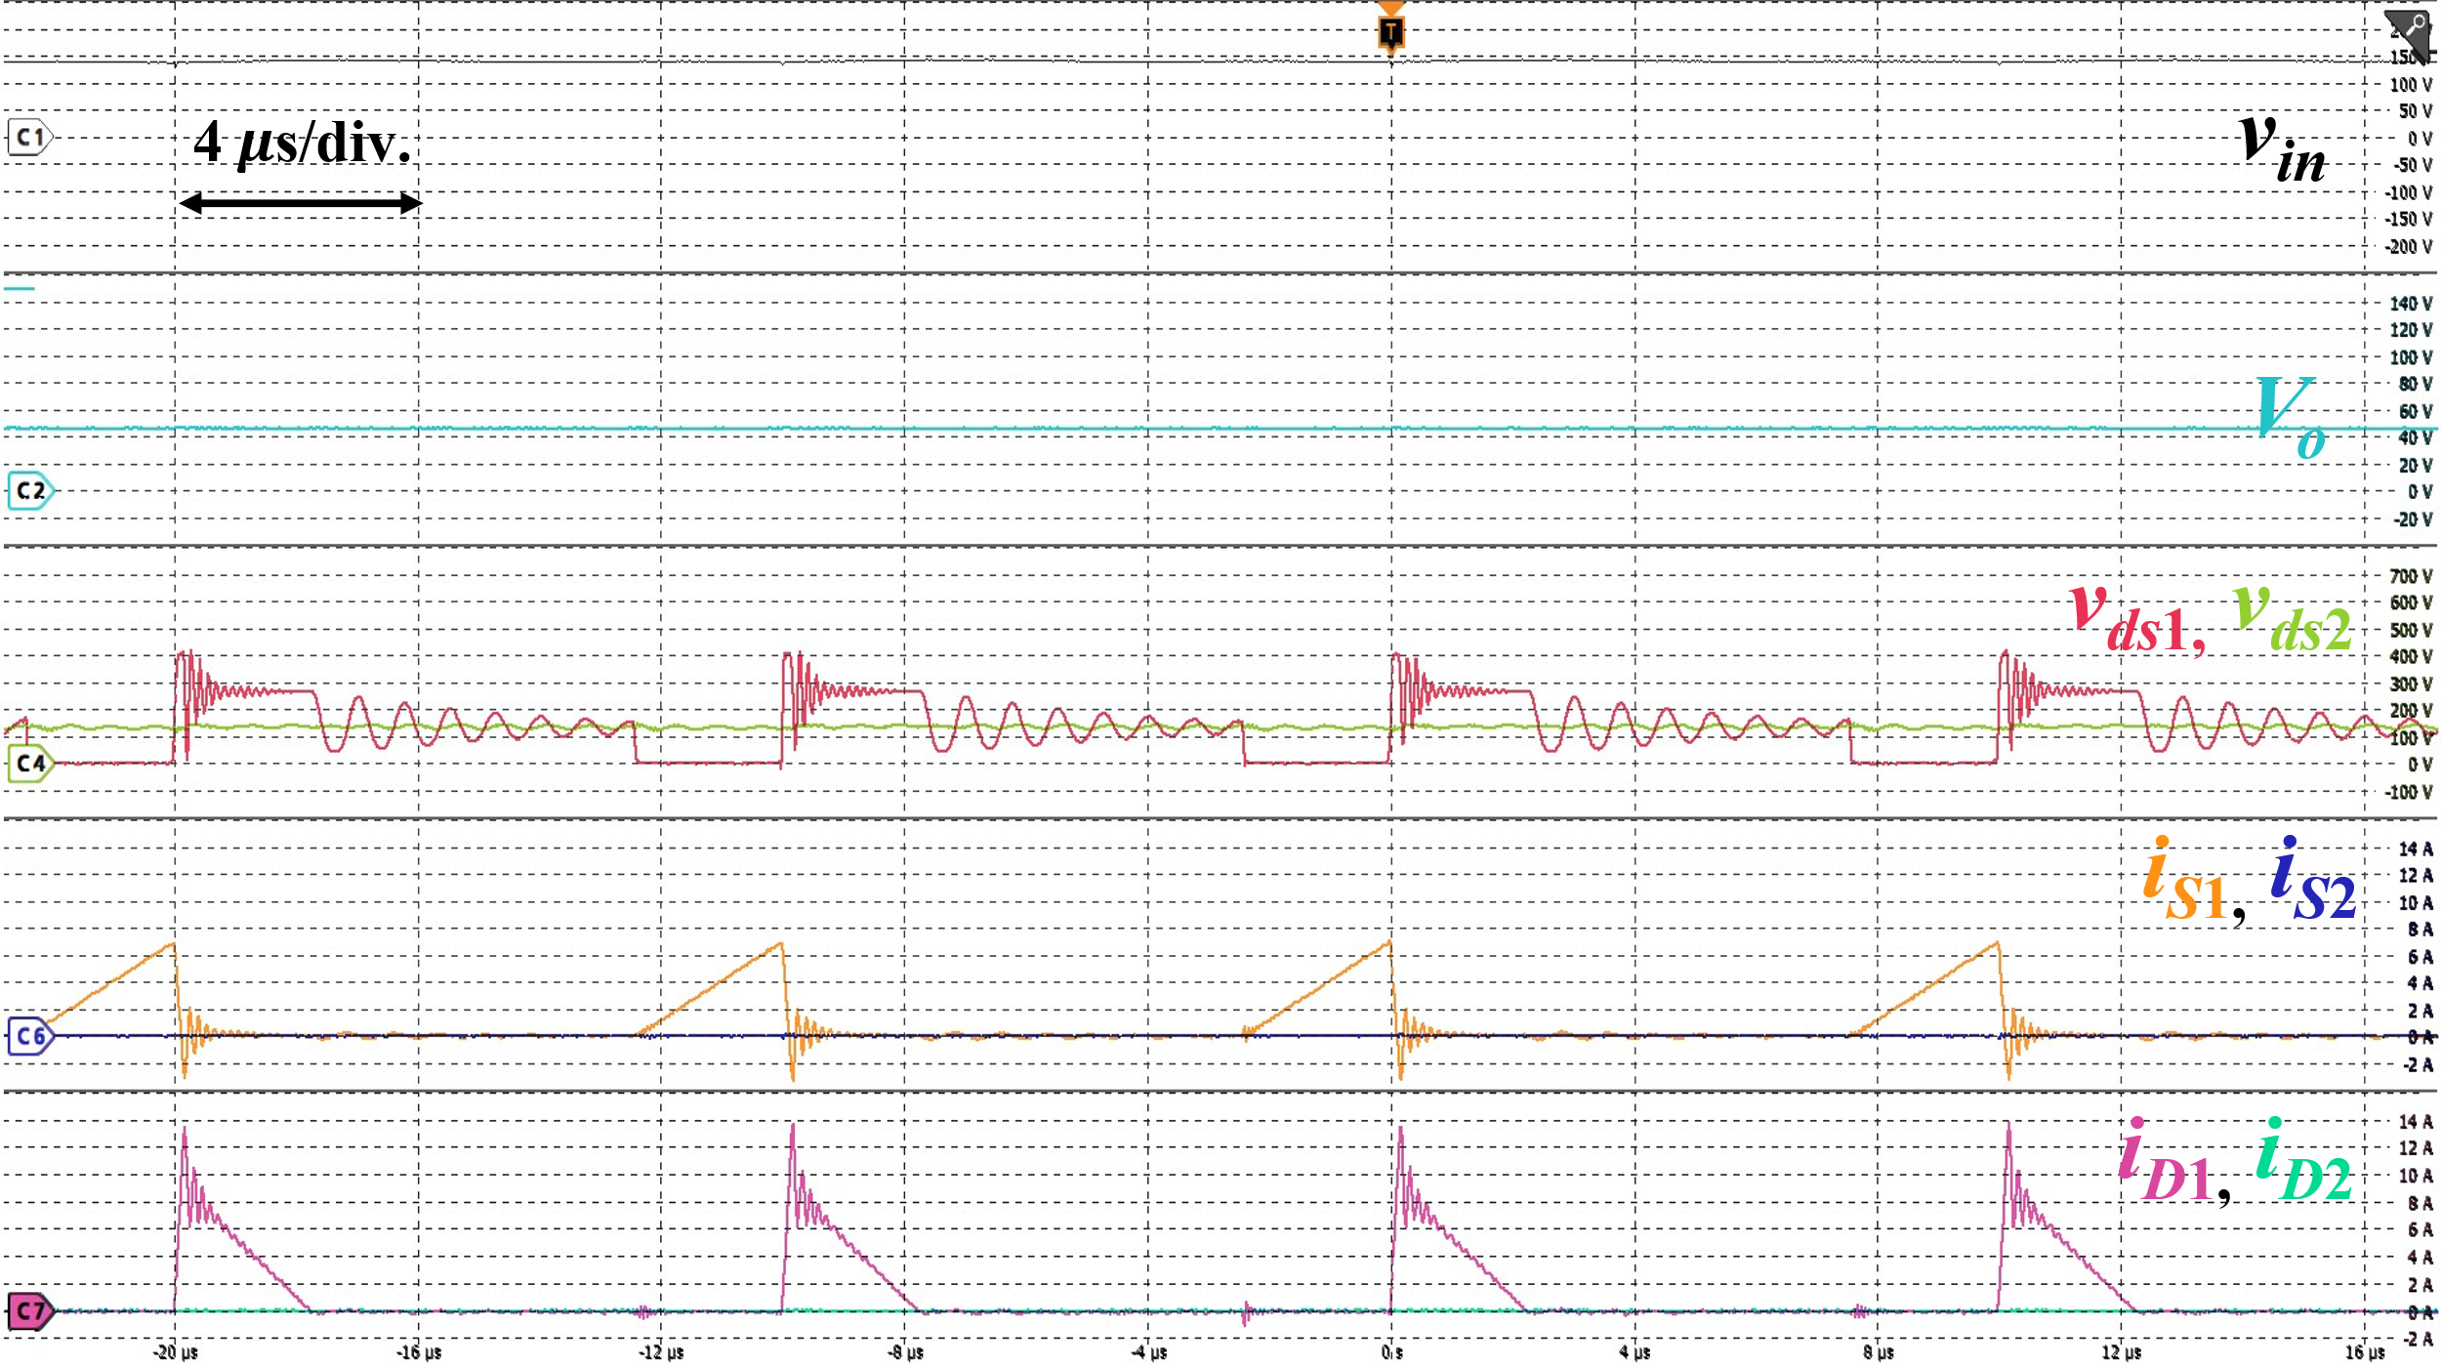  (d)  Fig. 17. Experimental waveforms of the proposed two-phase interleaved flyback rectifier at (a) and (b): 100 W, two-phase AC drive; (c): 240 W, two-phase AC drive; (d): 32.5 W, single-phase AC drive. For (a) and (b): $v_{in}$: 50 V/div., $V_{o}$: 10 V/div., $v_{ds1}$, $v_{ds2}$: 100 V/div., $i_{S1}$, $i_{S2}$: 1 A/div., $i_{D1}$, $i_{D2}$: 5 A/div.; For (c): $v_{in}$: 50 V/div., $V_{o}$: 10 V/div., $v_{ds1}$, $v_{ds2}$: 100 V/div., $i_{S1}$, $i_{S2}$: 2 A/div., $i_{D1}$, $i_{D2}$: 5 A/div.; For (d): $v_{in}$: 50 V/div., $V_{o}$: 20 V/div., $v_{ds1}$, $v_{ds2}$: 100 V/div., $i_{S1}$, $i_{S2}$: 2 A/div., $i_{D1}$, $i_{D2}$: 2 A/div. | (in Section V, Fig. 17)  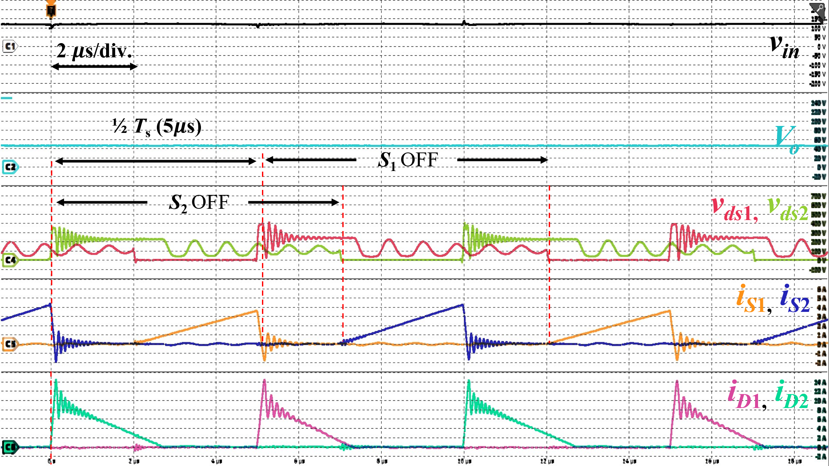  (b)  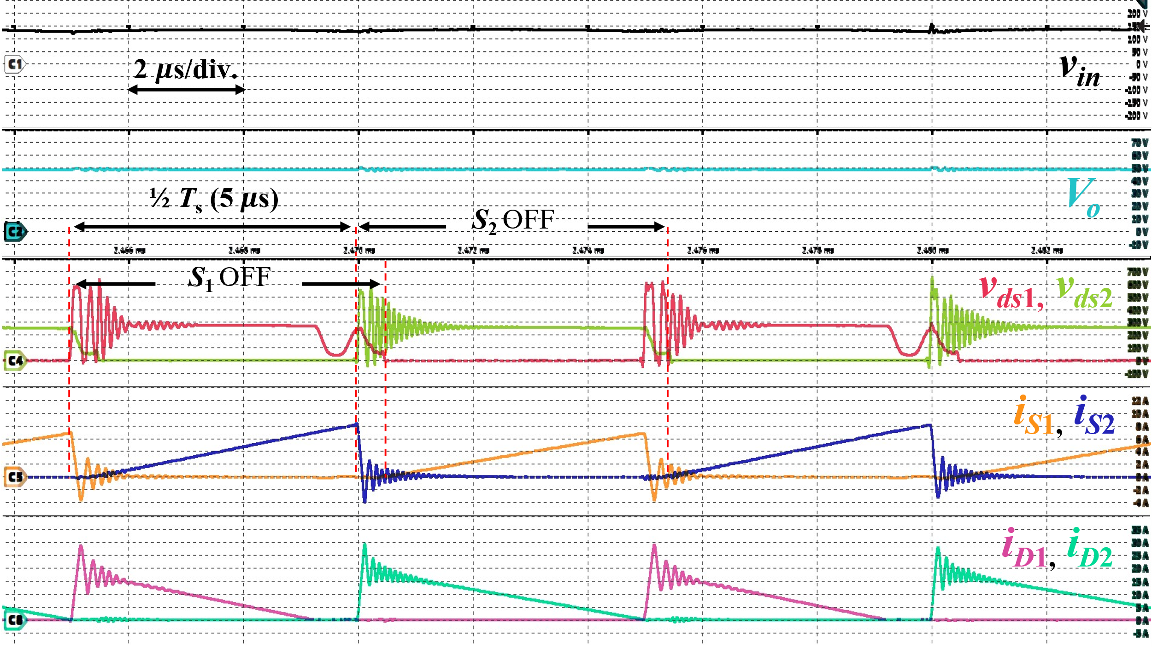  (c)  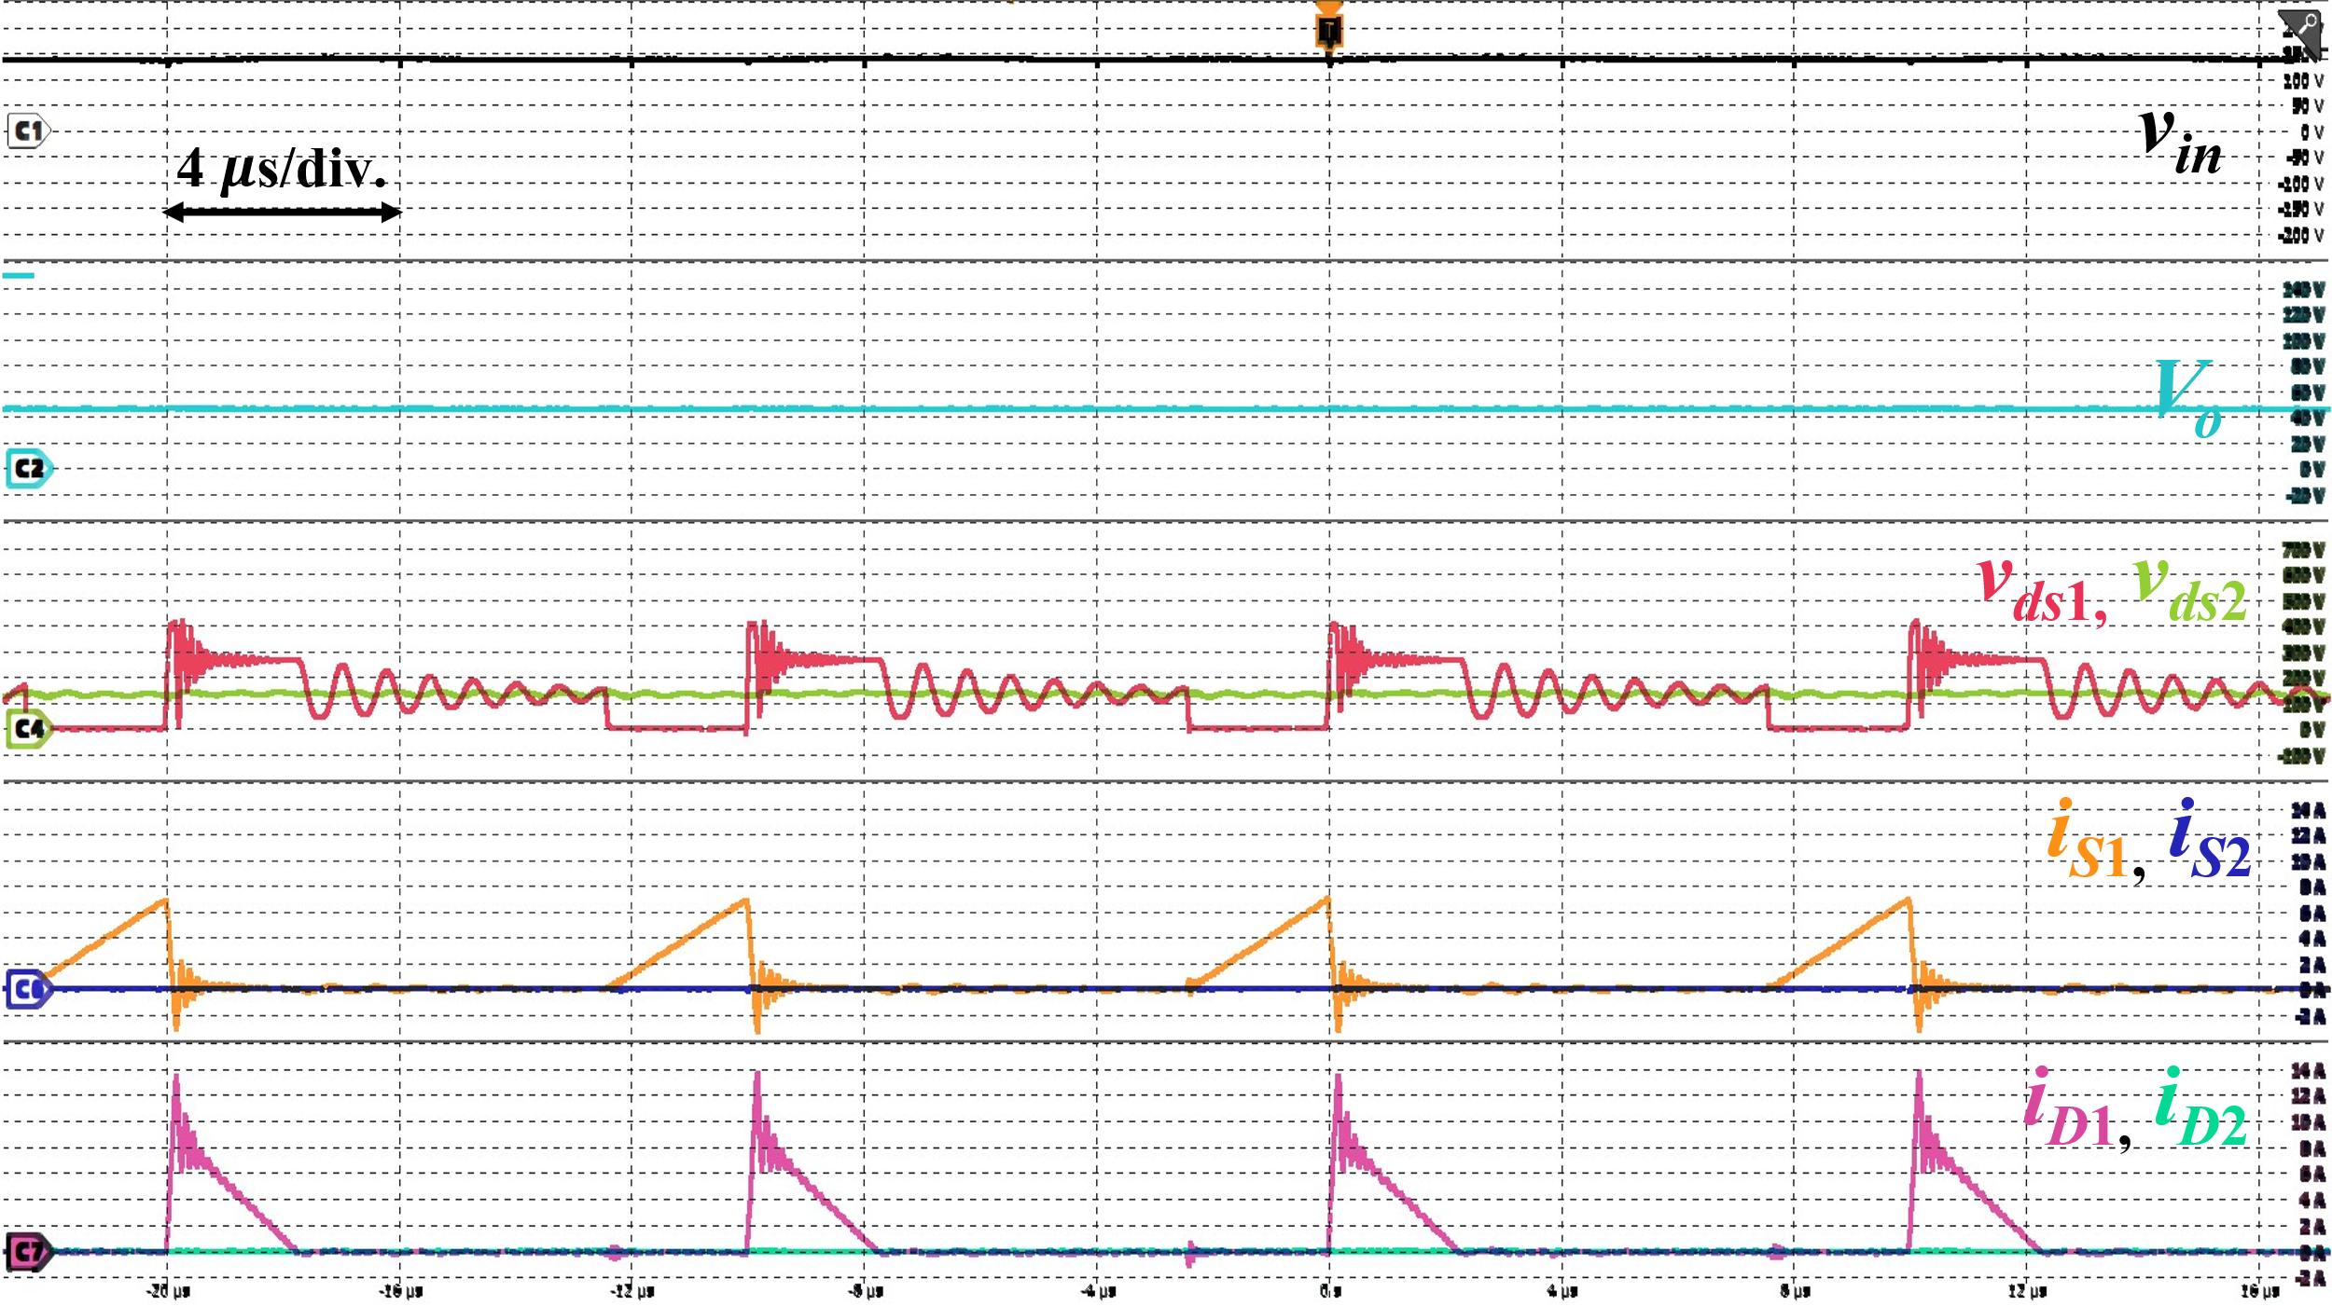  (d)  Fig. 17. Experimental waveforms of the proposed two-phase interleaved flyback rectifier at (a) and (b): 100 W, two-phase AC drive; (c): 240 W, two-phase AC drive; (d): 32.5 W, single-phase AC drive. For (a) and (b): $v_{in}$: 50 V/div., $V_{o}$: 10 V/div., $v_{ds1}$, $v_{ds2}$: 100 V/div., $i_{S1}$, $i_{S2}$: 1 A/div., $i_{D1}$, $i_{D2}$: 5 A/div.; For (c): $v_{in}$: 50 V/div., $V_{o}$: 10 V/div., $v_{ds1}$, $v_{ds2}$: 100 V/div., $i_{S1}$, $i_{S2}$: 2 A/div., $i_{D1}$, $i_{D2}$: 5 A/div.; For (d): $v_{in}$: 50 V/div., $V_{o}$: 20 V/div., $v_{ds1}$, $v_{ds2}$: 100 V/div., $i_{S1}$, $i_{S2}$: 2 A/div., $i_{D1}$, $i_{D2}$: 2 A/div.

To Reviewer 3
We authors appreciate your valuable comments. The revised parts are indicated by red texts in the manuscript.
Comments to the Author
This paper analyzes the design and implementation of an interleaved Flyback converter based on magnetic integration. My comments are as follows:
- The reviewers suggested including efficiency tests and comparing the results with other similar state-of-the-art topologies, but the authors did not adopt this recommendation.
- The efficiency curves provided in the authors' response are difficult to read due to the excessively wide range of the vertical axis. Furthermore, for an interleaved flyback converter, the prototype's efficiency is merely 85%—a figure far too low to meet the requirements for power electronic converters. While component selection certainly plays a significant role, the efficiency should not be this poor; such results suggest a fundamental flaw in the coupled transformer design or indicate that the topology itself may be incapable of achieving high efficiency.
We sincerely thank the reviewer for their critical feedback. Because Comments 1 and 2 both address the efficiency of the converter, we have combined our responses to address these concerns cohesively.

First, we apologize for the poor readability of the efficiency curve provided in our previous response. We have rescaled the vertical axis of the plots to closely match the peak efficiency, removing unnecessary empty space to clearly display the data range. As measured using a Hioki PW8001 Power Analyzer, the efficiency peaks at approximately 84.7% near full load in two-phase drive. Following your recommendation, we have also added the zoomed-in efficiency curve from 40 W to 250 W of input power and its corresponding analysis into a new Section V-C in the revised manuscript. Please note that we have included this efficiency evaluation not to claim an improvement in conversion efficiency, but simply to provide the baseline hardware characteristics of our proof-of-concept prototype, as our primary focus is on magnetic decoupling and volume reduction.

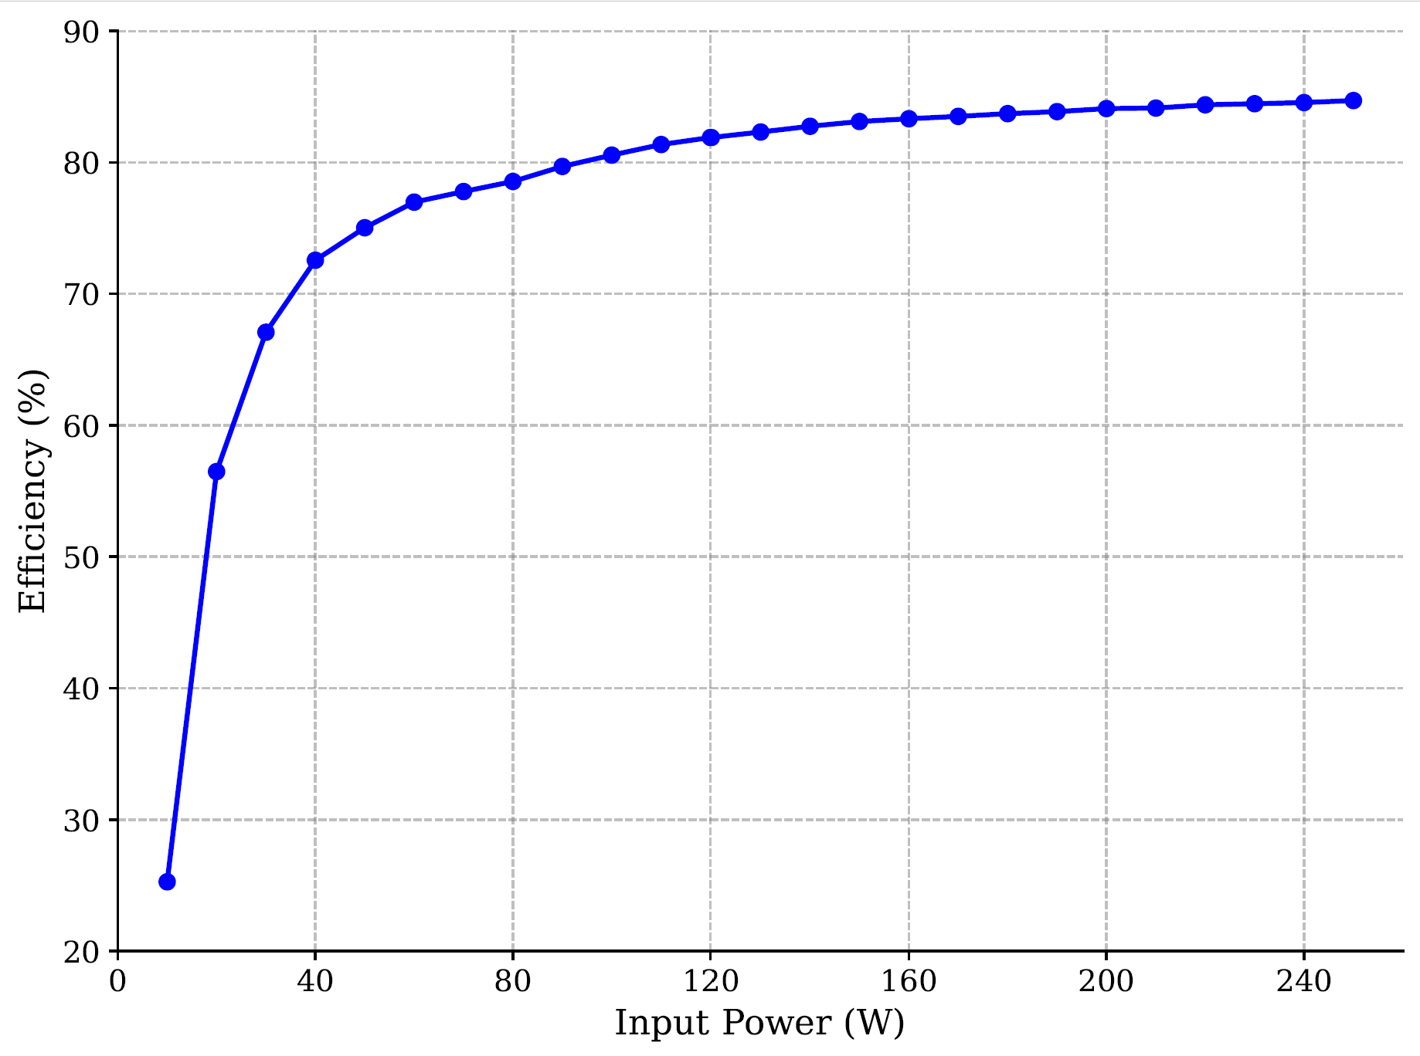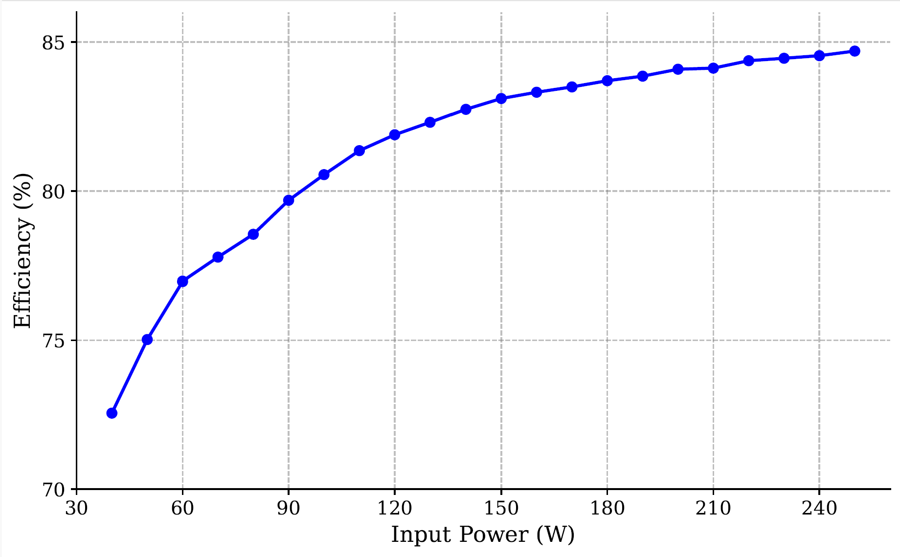
(a) (b)
Fig. System-level efficiency curve for the operation of the two-phase interleaved flyback rectifier with the
proposed magnetic component: (a) efficiency curve across the entire load range, (b) efficiency curve from
40 W to 250 W input power.

Regarding the concern that this efficiency might indicate a fundamental flaw in a "coupled" transformer design, we would like to gently clarify the specific nature of our topology and the primary scope of this research.

First, the proposed magnetic structure is explicitly designed to be decoupled (non-coupled). By physically separating the flux paths within a single standard EE-core, the design intentionally avoids the circulating currents across multi-phase operation that can often limit traditional coupled designs.

Second, we understand the reviewer’s concerns about the reported peak efficiency of around 85%. While we understand that the reported peak efficiency of ~85% is not high, we believe that it is not unusually low either. We acknowledge that flyback converters in this power domain can achieve efficiencies of 90% and greater [A], [B], [C], [D], [E]. However, we also found that an efficiency of approximately 80% to 85% is widely reported across various implementations: [F] achieves a maximum efficiency of 83%, [G] achieves 85.4%, [H] achieves 85%, [I] achieves 80 to 85%, [J] achieves 88%, [K] shows around 80 to 85% using RCD snubbers, and [L] shows around 82%. The references mentioned in this paragraph are mentioned in the last part of this comment, after showing the revised parts of the manuscript, in pages 18 to 19.

We note that the primary objective of this paper is to validate the feasibility of achieving independent, two-phase operation through structural magnetic decoupling within an integrated component. Because our prototype was constructed for a proof-of-concept evaluation, we utilized standard, dissipative RCD snubber circuits to protect the switches against surge voltages, which naturally limits the measured efficiency. Nevertheless, because our converter has not yet undergone system-level optimization, we note that the efficiency can certainly be improved in future iterations through targeted magnetic optimization, active clamp circuits, modified topology configurations, or advanced control techniques.

Finally, regarding the recommendation to include an efficiency comparison with other state-of-the-art topologies, we highly appreciate the perspective of the reviewer. However, because experimental efficiencies in literature depend heavily on specific semiconductor devices, topology configurations, control methods, and auxiliary snubbers, a direct numerical efficiency comparison may not accurately reflect the isolated performance of the magnetic component itself. Instead, we have expanded our comparison to focus on the structural and operational trade-offs of state-of-the-art interleaved flyback topologies, as summarized in Table I of the revised manuscript below.

Please see the following pages for the changes that have been implemented.

Before revision | After revision
(in Section I, 11th Paragraph)  Structural decoupling approaches have been explored to bypass these circulating currents and accommodate the variable load requirements of USB PD, offering an alternative to control-based phase shedding. Some approaches design decouples phases by separating the flux paths using 3-D orthogonal flux core geometries [34], [35]. However, these custom cores constrain commercial manufacturability and increases fabrication costs. Another proposed solution is an integrated nonlinear coupled inductor designed to decouple four phases at light loads [18]. Achieving this variable coupling requires  customized, multi-piece L- and T-shaped core assemblies with manually configured geometries, introducing tight assembly tolerances and manufacturing complexity. | (in Section I, 11th Paragraph)  Structural decoupling approaches have been explored to bypass these circulating currents and accommodate the variable load requirements of USB PD, offering an alternative to control-based phase shedding. Some approaches design decouples phases by separating the flux paths using 3-D orthogonal flux core geometries [34], [35]. However, these custom cores constrain commercial manufacturability and increases fabrication costs. Another proposed solution is an integrated nonlinear coupled inductor designed to decouple four phases at light loads [18]. Achieving this variable coupling requires  customized, multi-piece L- and T-shaped core assemblies with manually configured geometries, introducing tight assembly tolerances and manufacturing complexity. To clarify the operational trade-offs among these existing approaches, a comprehensive comparison of state-of-the-art interleaved flyback topologies and their magnetic configurations is summarized in Table I.

Before revision | After revision
N/A | (Newly added Table I)

Before revision | After revision
N/A | (after Section V-B)  C. System-level Efficiency Measurements  To characterize the baseline operation of the proof-of-concept prototype, the system-level efficiency of the converter was measured at a $v_{in}$ of 100 V_{rms}, $V_{O}$ of 48 V, and $f_{s}$ of 100 kHz up to an input power of 250 W using a Hioki PW8001 Power Analyzer. Fig. 19 illustrates the measured efficiency curve during two-phase interleaved operation. The converter achieves a peak efficiency of approximately 84.7% at full load.  The primary objective of this study was to validate the fundamental magnetic decoupling of the integrated transformer, rather than optimizing system-level efficiency. To ensure robust operation during these initial magnetic validations, standard RCD snubbers were utilized. Losses associated with these snubbers are expected to reduce the measured efficiency. While the current prototype demonstrates volume reduction and independent magnetic operation between two phases, further efficiency improvements are anticipated in future iterations through the implementation of active clamp circuits, new topology configurations, control techniques and optimization of transformer design.  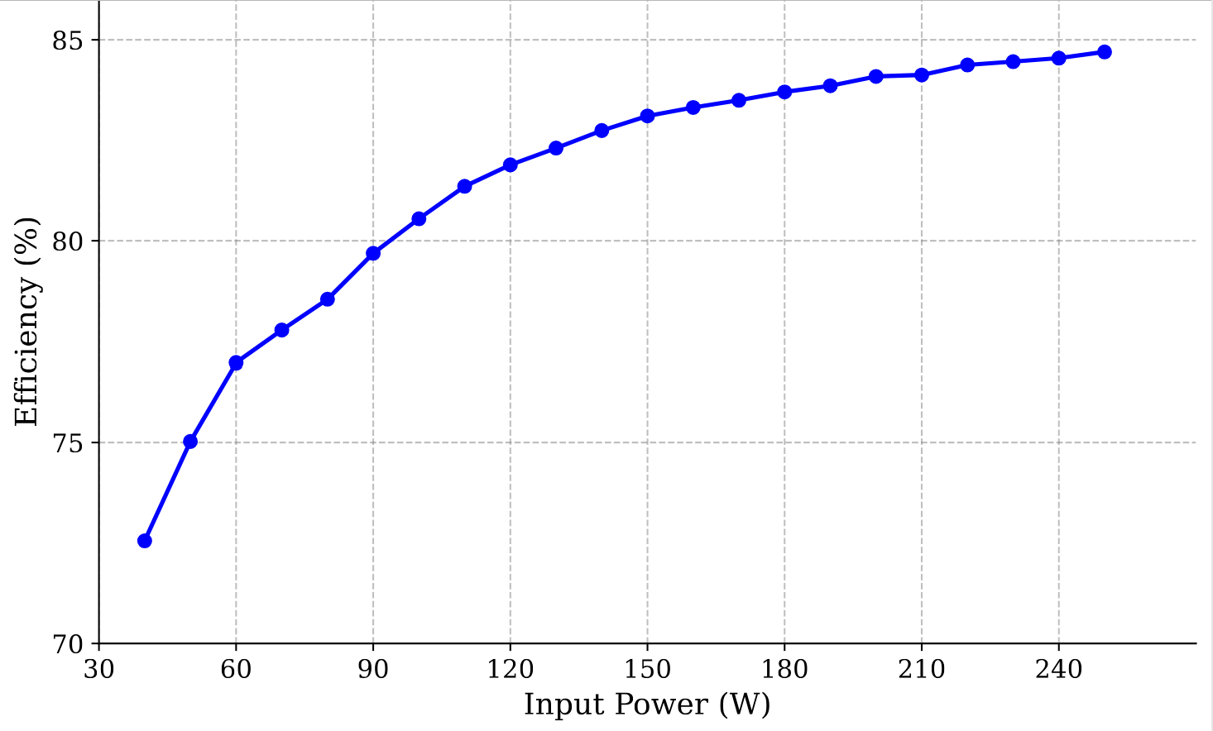  Fig. 19. Efficiency curve of the proposed interleaved flyback rectifier with the integrated transformer, up to full-load operation of 240 W.

References mentioned for this comment:

[A] Y. Yang et al., "A Novel Multiplexed Active Clamping Auxiliary Branch for 200 W Interleaved Flyback Microinverter Prototype to Achieve 95.8% Efficiency," in IEEE Transactions on Power Electronics, vol. 41, no. 10, pp. 18099-18116, Oct. 2026, doi: 10.1109/TPEL.2026.3695019.

[B] M. A. Rezaei, K. -J. Lee and A. Q. Huang, "A High-Efficiency Flyback Micro-inverter With a New Adaptive Snubber for Photovoltaic Applications," in IEEE Transactions on Power Electronics, vol. 31, no. 1, pp. 318-327, Jan. 2016, doi: 10.1109/TPEL.2015.2407405.

[C] Y. C. Hsieh, M. R. Chen and H. -L. Cheng, "An Interleaved Flyback Converter Featured With Zero-Voltage Transition," in IEEE Transactions on Power Electronics, vol. 26, no. 1, pp. 79-84, Jan. 2011, doi: 10.1109/TPEL.2010.2051817.

[D] T. J. Liang, K. H. Chen and J. F. Chen, "Primary Side Control For Flyback Converter Operating in DCM and CCM," in IEEE Transactions on Power Electronics, vol. 33, no. 4, pp. 3604-3612, April 2018, doi: 10.1109/TPEL.2017.2709811.

[E] L. Wang, H. Li and S. Li, "Burst Mode Control of Active-Power-Decoupling Integrated Active Clamp Flyback PFC Rectifiers," in IEEE Transactions on Power Electronics, vol. 38, no. 5, pp. 6337-6350, May 2023, doi: 10.1109/TPEL.2023.3244179.

[F] Y. G. Kim et al., "Low-Cost Universal Multi-Mode Digital Compensator Design for Flyback Converters With Full Digital Feedback," in IEEE Access, vol. 12, pp. 170840-170850, 2024, doi: 10.1109/ACCESS.2024.3498032

[G] Analog Devices, Inc., "AD-PS3803-RD — System Level Documentation," Analog Devices System Level Documentation. [Online]. Available: https://analogdevicesinc.github.io/system-level/solutions/reference-designs/ad-ps3803-rd/. [Accessed: Oct. 24, 2026].

[H] S. Y. Tseng and J. H. Fan, "Buck-Boost/Flyback Hybrid Converter for Solar Power System Applications," Electronics, vol. 10, no. 4, p. 414, 2021, doi: 10.3390/electronics10040414.

[I] S. F. Graziani, T. V. Cook and B. M. Grainger, "Isolated Flying Capacitor Multilevel Converters," in IEEE Open Journal of Power Electronics, vol. 3, pp. 197-208, 2022, doi: 10.1109/OJPEL.2022.3160049.

[J] Y. C. Li and C. L. Chen, "A Novel Primary-Side Regulation Scheme for Single-Stage High-Power-Factor AC–DC LED Driving Circuit," in IEEE Transactions on Industrial Electronics, vol. 60, no. 11, pp. 4978-4986, Nov. 2013, doi: 10.1109/TIE.2012.2224080.

[K] P. Thummala, H. Schneider, Z. Zhang, Z. Ouyang, A. Knott and M. A. E. Andersen, "Efficiency Optimization by Considering the High-Voltage Flyback Transformer Parasitics Using an Automatic Winding Layout Technique," in IEEE Transactions on Power Electronics, vol. 30, no. 10, pp. 5755-5768, Oct. 2015, doi: 10.1109/TPEL.2014.2379439.

[L] Y. C. Li and C. L. Chen, "A Novel Primary-Side Regulation Scheme for Single-Stage High-Power-Factor AC–DC LED Driving Circuit," in IEEE Transactions on Industrial Electronics, vol. 60, no. 11, pp. 4978-4986, Nov. 2013, doi: 10.1109/TIE.2012.2224080.

- The paper should present PFC voltage and current waveforms to substantiate the power factor claims. Typically, an uncontrolled rectifier with capacitive filtering yields a power factor of only 0.6–0.7 in the absence of PFC modulation.
We sincerely thank the reviewer for the valuable feedback. We completely agree that the power factor (PF) and input-current THD are critical metrics for PFC flyback rectifiers. Our prototype was constructed without a grid-side EMI filter to focus on validating the magnetic decoupling of the proposed integrated core. However, the experimental waveforms in Fig. 17 (a) (Fig. 18(a) in the revised manuscript) clearly demonstrate the inherent PFC envelope tracking the input AC voltage. Because the inherent DCM PFC mechanism is already a well-established characteristic of this topology, maximizing the absolute value of the power factor was not the primary focus of our physical prototype. We would also like to emphasize that the proposed magnetic integration does not alter the fundamental electrical principle of the converter. The inherent DCM PFC mechanism remains identical to that of a conventional topology utilizing discrete transformers. To verify that the proposed integrated magnetic structure preserves this inherent PFC capability, we have conducted a comprehensive simulation in PLECS Standalone 5.0 with a standard differential-mode EMI filter (L_{f} = 100 $μ$H, C_{f} = 1 $μ$F) to obtain an accurate estimate.

As shown in the table below, we also compared the proposed integrated transformer against a conventional interleaved flyback baseline using two discrete transformers with matched magnetizing inductance L_{m} of 82.8 $μH$ and turns ratio n = 3. The topology with the proposed magnetic component can preserve PFC, exhibiting PF and input-current THD performance that closely matches the conventional discrete setup across the extremes of the operating range, maintaining PF > 0.95 at all representative points.

We have added simulated PFC waveforms as well in two operating points as a visual reference for the reviewers. As can be seen in the figure below, PFC occurs.
(a) (b)
Fig. Key simulated PFC waveforms of the proposed two-phase interleaved flyback rectifier showing v_{in}, v_{o}, i_{in}, i_{S1} and
i_{S2}, and v_{ds1} and v_{ds2} with v_{in}, V_{out}, and P_{O} of: (a) 100 V_{rms}, 48 V, and 240 W and (b) 240 V_{rms}, 48 V, and 240 W.

We have added these analyses in Section III-B to reflect these changes and clarifications as indicated below.
Before revision | After revision
N/A | (in Section III-B, after the 1st paragraph)  Furthermore, to substantiate the PFC capability of the proposed integrated structure, a performance analysis was conducted across several operating points. For reference, the proposed design was compared against a conventional two-phase interleaved flyback rectifier utilizing two discrete transformers with an identical n = 3 and L_{m} = 82.8 $μ$H. To extract clean grid-side AC waveforms and accurately evaluate harmonic distortion, a standard differential-mode EMI filter with L_{f} = 100 $μ$H, C_{f} = 1 $μ$F was incorporated into the simulation model.  As summarized in Table IV, the proposed non-coupled integrated transformer maintains a high PF of >0.95 and low current THD across various input voltages and load conditions. Crucially, the fundamental decoupling of the magnetic structure ensures that its PF and THD performance remains nearly identical to that of the conventional discrete implementation and additionally validates the claims of inherent PFC operation in DCM in Section II. To provide a clear visual reference of this capability, the simulated PFC waveforms at the operating points of $v_{in}$, $V_{O}$, and $P_{O}$ of 100 V_{rms}, 48 V, and 240 W, and 100 V_{rms}, 48 V, and 240 W are shown in Fig. 13(a) and Fig. 13(b) respectively.
N/A | (Newly added Table IV)
N/A | (Newly added Fig. 13)  (a)  (b)  Fig. 13. Key simulated PFC waveforms of the proposed two-phase interleaved flyback rectifier with v_{in}, V_{out}, and P_{O} of: (a) 100 V_{rms}, 48 V, and 240 W and (b) 240 V_{rms}, 48 V, and 240 W.

- End of the response letter-

